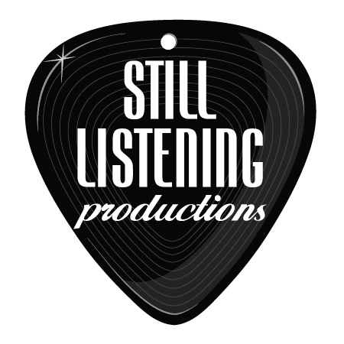

Live Music Selections by Jonny Tarr

Ceremony Suggestions:

Lovely Instrumentals – Good for solo guitar:
Gravity – John Mayer
Here Comes the Bride – Bridal Chorus/Wagner
Here Comes the Sun – Beatles
I Wanna Hold Your Hand (slow) - Beatles
Fields of Gold – Sting
Can’t Help Falling in Love – Elvis Presley
Yellow – Coldplay
I’m Yours – Jason Mraz
Hallelujah – Leonard Cohen
Wonderful Tonight – Eric Clapton

Processionals w/ or w/o Vocals:
The Sweetest Thing – U2
All I Want is You – U2
Canon in D – Pachelbel
Come Away With Me – Norah Jones
Here Comes the Bride – Bridal Chorus/Wagner
Here Comes the Sun – Beatles
I Will Wait – Mumford and Sons
Somewhere Over the Rainbow – Israel Kamakawiwo
You and Me – Penny and the Quarters

A lively Recessional:
Abracadabra – The Steve Miller Band
All You Need is Love – Beatles
Best Day of My Life – American Authors
Better Together – Jack Johnson
Celebration – Kool and the Gang
Everything – Michael Buble
Hey Yaa - Outkast
How Sweet It Is – James Taylor
It Must Be Love – Labi Siffre
Locked Out of Heaven – Bruno Mars
On Top of the World – Imagine Dragons
Signed, Sealed Delivered – Stevie Wonder
Thunder – Imagine Dragons
Trouble – Ray LeMontagne
Viva La Vida - Coldplay
When I’m kissing My Love – Bill Withers
You Make My Dreams Come True – Hall &Oates

Unique Live Dances:

First dance ideas:
All of Me – John Legend
Cold Water – Justin Bieber
Cupid – Sam Cooke
Diamonds on the Soles of Her Shoes – Paul Simon
Earth Angel – The Penguins
I Don’t Wanna Miss a Thing – Aerosmith
I’m Gonna Be (500 Miless) – The Proclaimers
In Your Eyes – Peter Gabriel
Let’s Get It On – Marvin Gaye
Let’s Stay Together – Al Green
Love Me Tender – Elvis Presley
Moondance – Van Morrison
Waiting for a Girl Like You - Foreigner
Your Love is King - Sade

Live Father-Daughter Dance Ideas:
Daughters – John Mayer
Father and Daughter – Paul Simon
I Will Always Love You – Whitney Houston
My Girl – Temptations
Sweet Child of Mine – Guns ‘n Roses
You Are So Beautiful – Joe Cocker
Lean on Me – Bill Withers
Stand By Me – Ben E. King
Stay With You – John Legend
Umbrella – Rihanna
When You Say Nothing at All – Alison Krauss
You Are the Best Thing – Ray LaMontagne
Your Song – Elton John

Live Mother-Son Dance Ideas:
In My Life – Beatles
Have I Told You Lately – Rod Stewart
How Deep is Your Love? – The Bee Gees
Imagine – John Lennon
My Wish – Rascal Flatts
Only You – Yaz
You’ve Got a Friend – James Taylor
Wonderful World – Louis Armstrong

Romantic Jams for Cocktail / Dinner
Babylon / This Year’s Love – David Gray
Budapest – George Ezra
Can’t Take My Eyes Off You – Frankie Valli
Champagne Supernova / Wonderwall– Oasis
Crazy Love – Van Morrison
Gravity – John Mayer
Every Little Thing She Does is Magic – The Police
Harvest Moon – Neil Young
Ho Hey – Lumineers
Human – The Killers
I Can’t Trust Myself Loving you – John Mayer
Just Can’t Get Enough – DePeche Mode
Just the Two of Us – Bill Withers
Just the Way You Are – Billie Joel
Just the Way You Are – Bruno Mars
Lean on Me – Bill Withers
Starlight - Muse
Stay With You – John Legend
The Sweetest Taboo - Sade
Umbrella – Rihanna
Viva La Vida / Clocks – Coldplay
Weather With You – Crowded House
Wicked Game – Chris Isaak
You Are the Best Thing – Ray LaMontagne
Your Song – Elton John

Acoustic Dance Party:
Ascension - Maxwell
Billie Jean – Michael Jackson
Blurred Lines – Robin Thicke
Can’t Feel My Face – The Weeknd
Closer – Ne-Yo
DJ Got Us Falling in Love – Usher
Don’t Stop Til You Get Enough – Michael Jackson
Do it Again – Steely Dan
Get Lucky – Daft Punk
Graceland – Paul Simon
Happy – Pharrell Williams
Higher and Higher – Jackie Wilson
I Feel Good – James Brown
I’m Still Standing – Elton John
Lovely Day – Bill Withers
Marry You – Bruno Mars
Pony - Ginuwine
Shake your body Down to the Ground – The Jacksons
She Drives Me Crazy – Fine Young Cannibals
Stuck in the Middle – Stealer’s Wheel
Sugar – Maroon 5
Superstition – Stevie Wonder
The Boys of Summer – Don Henley
The Way You Make Me Feel – Michael Jackson
Uptown Funk – Bruno Mars
Use Me – Bill Withers

Mellow Vibes:
Babylon – David Gray
Cake by the Ocean – D.A.N.C.E.
Easy (Like Sunday Morning) – Lionel Richie
Free – Zac Brown
Take it to the Limit – The Eagles
Human Nature – Michael Jackson
I Can See Clearly Now – Johnny Nash
Into the Mystic – Van Morrison
Jammin’ – Bob Marley
One – Love Bob Marley
Red Red Wine – UB40
Royals - Lorde
Steal My Kisses – Ben Harper
Sea of Love – Cat Power
Sittin’ On the Dock of the Bay – Otis Redding
Summer Breeze – Seals and Croft
Three Little Birds – Bob Marley
Waiting in Vain – Bob Marley
Watching the Detectives – Elvis Costello

Singalong Jams –
Broken Wings – Mr Mister
Brown Eyed Girl – Van Morrison
Don’t Stop Believin’ – Journey
Free Fallin’ – Tom Petty
Horse With No Name - America
I Want It That Way – Backstreet Boys
Living on a Prayer – Bon Jovi
Sex on Fire – Kings of Leon
Stand By Me – Ben King
Sweet Caroline – Neil Diamond
Sweet Home Alabama – CCR
The Joker – Steve Miller Band
Your Love – The Outfield

*** This is a partial list. Please inquire if you have special requests that may not be on this list. One to two new songs can be learned per eve

