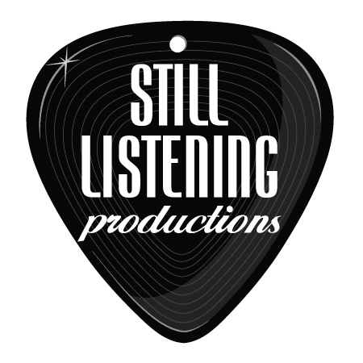
Lee Coulter

Live Music suggestion list for Your Wedding and Cocktail/ Dinner Hour

I’m Yours – Jason Mraz
Better Together – Jack Johnson
Somewhere Over The Rainbow/What a Wonderful World – IZ (Hawaiian style)
Your Song - Elton John
59th Street Bridge Song (Feeling Groovy) - Simon & Garfunkel
Peaceful Easy Feeling – The Eagles
Make You Feel My Love – Bob Dylan/Adele
Yellow - Coldplay
Fields of Gold - Sting
When You Say Nothing at All - Alison Kraus
Your Body is a Wonderland - John Mayer
Babylon - David Gray
Crash Into Me - Dave Matthews Band
I Can Hear Music – The Beach Boys
Home – Michael Buble
Chasing Cars – Snow Patrol
Smooth - Santana
Lady - Lenny Kravitz
Wonder - Natalie Merchant
Falling In Love Again - Brian Ferry
Save Tonight - Eagle Eye Cherry
Waiting In Vain - Bob Marley
Ain't Too Proud to Beg - Temptations
Still Haven't Found What I'm Looking For - U2
Heard it Through the Grapevine - Marvin Gaye
No Such Thing – John Mayer
Flake - Jack Johnson
Zephyr Song - Red Hot Chilli Peppers
Teenage Dream – Katy Perry
Don’t Know Why – Norah Jones
Land Downunder – Men at Work

