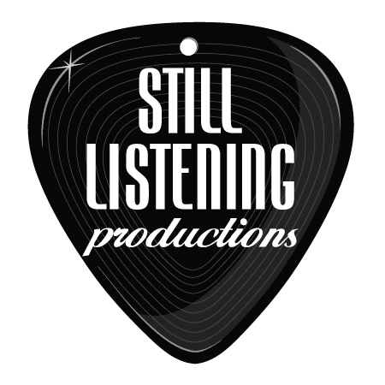
Tolan Shaw

Live Music for Your Wedding and Cocktail/ Dinner Hour

Here Comes the Sun- Beatles (good prelude song)
Blackbird acoustic- Beatles (nice ceremony acoustic music)
Wonderful Tonight- Eric Clapton (acoustic version nice for ceremony)
Canon in D (nice prelude)
Is This Love- Bob Marley (nice for recessional)
The Way I Am- Ingrid Michaelson (good for recessional, or prelude)
Steal My Kisses- Ben Harper (nice recessional)
How Sweet it is To Be Loved By You- Marvin Gaye (nice recessional)
Be Your Man- Tolan Shaw (nice recessional, or acoustic for prelude)
Sittin’ on the Dock of the Bay- Otis Redding
In A Little While- U2
One- U2
Still Haven’t Found What I’m Looking For- U2
Moondance- Van Morrison
Trouble- Ray Lamontagne
You Are the Best Thing- Ray Lamontagne
Yellow- Coldplay
Viva la Vida- Coldplay
Clocks- Coldplay
What I Got- Sublime
Don’t You Evah- Spoon
My Girl- The Temptations
Free Fallin- Tom Petty
Queen of California- John Mayer
Waiting on the World to Change- John Mayer
Tighten Up- Black Keys
Little Black Submarines- Black Keys
All You Need is Love- Beatles
In My Life- Beatles
I’ve Just Seen a Face- Beatles
I Wanna Hold Your Hand- Beatles
Stir it Up- Bob Marley
Three Little Birds- Bob Marley
Castles Made of Sand- Jimi Hendrix
The Wind Cries Mary- Jimi Hendrix
You Send Me- Sam Cooke
Only Sixteen- Sam Cooke
Fly Me to the Moon- Frank Sinatra
Ho Hey- The Lumineers
Diamonds on the Inside- Ben Harper
Everything- Michael Buble
I’m Yours- Jason Mraz
Better Together- Jack Johnson
Falling Slowly- Glen Hansard (Once Soundtrack)
Ain’t No Sunshine- Bill Withers
Lean on Me- Bill Withers
Stand by Me- Ben E King
Hallelujah- Leonard Cohen
Unstoppable- Tolan Shaw
Meant to Be- Tolan Shaw

