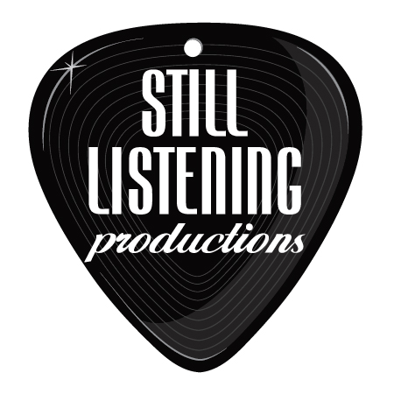
Live Music for Your Wedding and Cocktail / Dinner Hour

Sample Choices:

Canon in D (instrumental)– Bridal Entrance / Wedding Party Entrance
Here Comes the Bride (instrumental) – Bridal Entrance
Here Comes the Sun – (Instrumental or Sung, bridal party entrance, or recessional)
Somewhere Over the Rainbow / Wonderful World – (Hawaiian version, great for bridal party processional or prelude)
Fields of Gold – Sting (Eva Cassidy arrangement – great for prelude or processional)
There is Love (The Wedding Song) – Paul Stookey
Is This Love – Bob Marley (a fun, lively recessional!)
How Sweet it Is – James Taylor (great for recessional)
Have a Little Faith in Me – John Hiatt (nice for prelude)
Come Away With Me – Norah Jones (great for prelude or bridal party)
You With Me – Michael Tiernan ( good prelude song)
1000 Years – Christina Perri (great processional too!)
I Will Wait – Mumford and Sons (Sounds rad slowed down for bridal party processional☺)
All I Want is You – U2
Can’t Help Falling In Love – Elvis Presley (nice as instrumental as well)
I’m Yours – Jason Mraz (great as instrumental too!)
Don’t Wake Up – Michael Tiernan
You And Me – Dave Matthews
Everything – Michael Buble
Wanted – Hunter Hayes
When Stars Go Blue – Ryan Adams
Whatever It Is – Zac Brown Band
Sweet Pea – Amos Lee
Feels Like Home – Chantal Krevaziak / Randy Newman
All I Want Is You – Tristan Prettyman
All My Life – David Wilcox
Love Song – The Cure
Just Like Heaven – The Cure
Viva La Vida – Coldplay
Ballad for My One True Love – Mason Jennings
California Stars - Wilco
Yellow - Coldplay
To Make You Feel My Love – Bob Dylan / Adele
No One – Alicia Keys
Every Day – Buddy Holly
1,2,3,4 – Plain White T’s
Keepin’ It Real – Mason Jennings
True Companion – Marc Cohn
Grow Old With You – Adam Sandler
Forever – Ben Harper
Not Fire, Not Ice – Ben Harper
The Question – Old 97’s
Such Great Heights – Acoustic Version, Postal Service
Flightless Bird – Iron and Wine
Marry Me – Train (good as instrumental)
Rhythm of Love – Plain White T’s
Better Together – Jack Johnson
Banana Pancakes – Jack Johnson
Angel – Jack Johnsom
Umbrella – Rihanna
Daughters – John Mayer
Good Riddance – Green Day
Crash – Dave Matthews
In Your Eyes – Peter Gabriel
All You Need is Love - Beatles
In My Life – Beatles
I Wanna Hold Your Hand – Beatles
Melt With You – Modern English
Harvest Moon – Neil Young
Signed, Sealed, Delivered – Stevie Wonder
Thank You – Led Zeppelin
When You Say Nothing At All – Allison Krauss
Every Little Thing She Does is Magic – The Police
Moondance – Van Morrison
Book of Love – Peter Gabriel
Falling Slowly – Glen Hansard / Theme from the movie “Once”
You’ve Got a Friend – Carole King / James Taylor
Wonderful Tonight – Eric Capton
The Story – Brandy Carlisle
Somebody – DePeche Mode
Your Guardian Angel – Red Jumpsuit Apparatus
You Make My Dreams Come True – Hall and Oates
Wagon Wheel – Old Crow Medicine Show
Babylon – David Gray
Be Mine – David Gray
They Bring Me to You – Joshua Radin
Only You – Yaz
Then – Brad Paisley
One Love – Bob Marley
Sea of Love – Cat Power
Stay With You – John Legend
The Way You Look Tonight – Sinatra
Forever – Chris Brown
Mirrors – Justin Timberlake
Love Somebody – Maroon 5
Come To Me – Goo Goo Dolls
God Only Knows – Beach Boys
Tenerife Sea – Ed Sheeran
Heavenly Day – Patty Griffin
Strawberry Swing – Coldplay
Til Kingdom Come - Coldplay
All of Me – John Legend
Best Day of My Life – American Authors
I Won’t Give Up – Jason Mraz
Top of the World – Imagine Dragons
Wildflowers – Tom Petty
Human – The Killers
Arms – Christina Perri
I’m So Glad – Royal Wood

