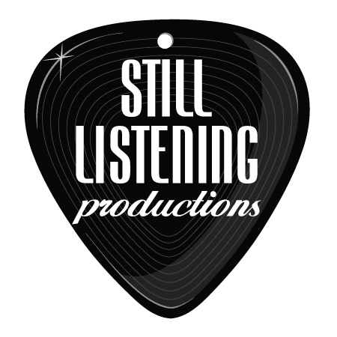
Joshua Bonas

Live Music for Your Wedding and Cocktail/ Dinner Hour

Songbird- Fleetwood Mac (Eva Cassidy version)
Fields of Gold- Sting (Great for Prelude or Processional)
How Sweet it Is- James Taylor (Great for Recessional)
History in the Making- Darius Rucker (Great for Recessional)
I Feel Fine- Beatles (Great for Recessional)
Home- Phillip Phillips
Just the Two of Us- Bill Withers
Bless the Broken Road- Rascal Flatts
Do You Remember- Jack Johnson
She’s Got a Way- Billy Joel
Can’t Help Falling in Love- Elvis
Love Is a Verb- John Mayer
Everything- Michael Buble
Love Song- The Cure
Just the Way You Are- Billy Joel
Green Eyes- Coldplay
To Make You Feel My Love- Bob Dylan
No One- Alicia Keys
1, 2, 3, 4- Plain White T’s
Forever- Ben Harper
Chasing Cars- Snow Patrol
Marry Me- Train
Stand By Me- Ben E. King
Umbrella- Rhianna
Crash- Dave Mathews
We’re In Heaven- Bryan Adams
Forever and Ever Amen- Randy Travis
In Your Eyes- Peter Gabriel
In My Life- Beatles
Harvest Moon- Neil Young
Thank You- Led Zepplin
Falling Slowly- Glen Hansard (Theme from movie “Once”)
Babylon- David Gray
The Lady in Red- Chris DeBurgh
Time After Time- Cyndi Lauper
I’m Yours- Jason Mraz
Danny’s Song- Loggins and Messina
Leather and Lace- Stevie Nicks
What A Wonderful World- Louis Armstrong
Kingdom Come- Coldplay
This Years Love- David Gray
Best of My Love- Eagles
Something In the Way She Moves- James Taylor
Love- John Lennon
Daughters- John Mayer
Ring of Fire- Johnny Cash
Making Memories of Us- Keith Urban
Can’t Take My Eyes Off of You- Frankie Valli
I Will Follow You Into the Dark- Death Cab for Cutie
The Only Exception- Paramore
You Are the Best Thing- Ray LaMontagne
Just the Way You Are- Boyce Avenue
Nothing But Love For You- Axwell
Use Somebody- Kings of Leon
Crazy Love- Van Morrison
Blue Eyes- Timmy Curan
Your Song- Sir Elton John
Here Comes the Sun- George Harrison
Going to the Chapel of Love- Dixie Cups

